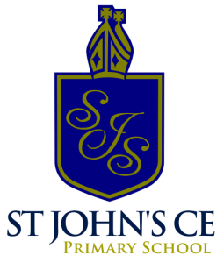

St John’s Music Development Plan
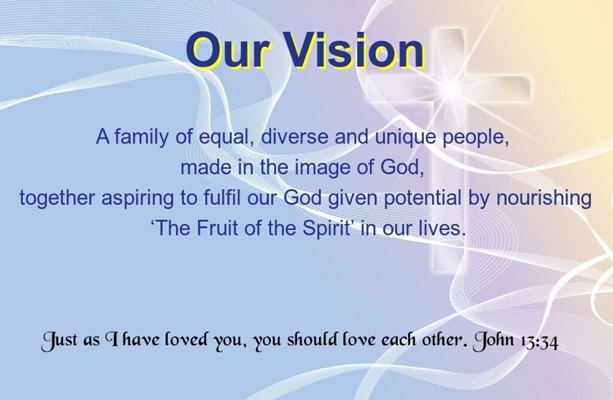

Overview
Detail | Information
Academic year that this summary covers | 2025-2026
Date this summary was published | September 2025
Date this summary will be reviewed | September 2026
Name of the school music lead | Chloe Burns
Name of school leadership team member with responsibility for music (if different) | Sarah Wynn
Name of local music hub | Walsall Music Education Service
Name of other music education organisation(s) (if partnership in place)
This is a summary of how our school delivers music education to all our pupils across three areas – curriculum music, co-curricular provision and musical experiences – and what changes we are planning in future years. This information is to help pupils and parents or carers understand what our school offers and who we work with to support our pupils’ music education.
Part A: Curriculum music
Our music curriculum enables:
- Pupils to enhance their performance skills by learning to play both tuned and untuned instruments, singing a wide range of songs, and rehearsing and performing in groups.
- Pupils to develop their composition abilities by creating musical patterns, exploring and organising sounds, and learning different methods of recording their work.
- Pupils to analyse and compare different sounds, explore musical concepts, and make improvements to their work, strengthening their appraisal skills.

Charanga
Teachers plan their lessons around our comprehensive music curriculum, utilizing the Charanga music scheme. This scheme is organized into half-termly themes, allowing teachers to engage all students effectively. The lessons incorporate a mix of teacher-led activities and opportunities for students to explore music independently, fostering both guided learning and creative expression. Charanga provides a structured approach that develops key skills in performance, composition, and appraisal, promoting well-rounded musical growth. Children develop their musical skills (finding the pulse, listening and playing back a rhythm, improvisation, internalising etc…) through games based around their topic’s genre/song. We teach a broad range of skills and expose the children to a wide variety of musical genres. For students with Special Educational Needs and Disabilities (SEND), personalised support is provided according to individual needs. For example, students who are sensitive to noise can use ear defenders during louder sessions. Teachers tailor their instruction and adjust lesson plans to ensure every student is appropriately challenged.
By using knowledge organisers, children can see exactly what they should be learning throughout a unit. Knowledge organisers are provided for each unit and contain information such as the focus learning for that unit, key vocabulary and background information on a specific genre or culture that the music originated from.

Curriculum Offer
The music curriculum at St John’s:
- Music lessons once a week (1 hour) following Charanga which aligns with the National Curriculum for Music.
- A coverage of a range of genres of music.
- All staff encourage the range of musical instruments used in lessons.
- Non-statutory guidance set out in the Music Model Curriculum:
  - Year 3 & 4 learn the recorder (6-week duration) with their class teacher under the supervision/ training of a music specialist from Walsall Music Hub.
  - Year 5 & 6 learn keyboards (6-week duration) with their class teacher under the supervision/ training of a music specialist from Walsall Music Hub.
- All children are engaged and actively participate in Music, including SEND children.
- All children are given the chance to perform in a show each year as part of the Music curriculum.

Music Lesson
Music is taught in lesson time to all pupils. Lessons are based on the guidance for teaching music from Key Stages 1 to 3 (National Curriculum) and follow Charanga which aligns with the National Curriculum.
Year group | Music teaching time (weekly)
Early Years | 30-minute lesson additional to a song of the week / nursery rhymes throughout the day. Chances to explore instruments and music during provision.
Year 1 - 6 | 1 hour a week

Music in our Early Years Foundation Stage
In the Early years, all children are taught music as an integral part of the learning covered during the academic year. All musical learning intentions within the EYFS are underpinned by the objectives of the early learning goals (ELGs).
Activities undertaken in EYFS provide essential skills and building blocks on which Key Stage can build in order for pupils to become ‘more musical’.
These include:
- Listening and responding to music, expressing their thoughts and feelings.
- Remember and sing entire songs in a group or on their own.
- Explore, engage and perform in music making and dance.
- Play instruments with increasing control to express their feelings and ideas.
Children in EYFS receive a minimum of 30 minutes direct teacher-led teaching of music per week where the Charanga units are taught whole class. In addition to this, Music is a big part of our EYFS as we have songs for routines, are familiar with Nursery Rhymes and access musical instruments in small groups during our provision times.

Part B: Co-curricular Music
St John’s offers a range of opportunities for pupils to sing and play music, outside of lesson time, including choirs, ensembles and bands, and allow pupils to make progress in music beyond the core curriculum. These include:
- Singing club run by Music lead (45 minutes weekly after school) - this is open to KS1 and KS2 children.
- KS2 children offered the opportunity to play woodwind or a brass instrument with no fee, instrument loaned through the hub.
- Children who take the opportunity to play an instrument can go on to achieve a grade.
- LAC children- weekly music lesson (funded)
- All children in KS1 and KS2 have singing assemblies once a week where songs are taught from our song bank. Additional to lyrics and tune, children are also taught to focus on their breathing and posture.
- Key stage one weekly singing assembly delivered by music lead- assemblies alive.

Part C: Musical experiences
Children at St John’s have a broad range of opportunities to be involved in other musical events, such as singing during Worship or the St John’s Family Service, Church events, concerts and shows, and trips to professional concerts.

Live Performances
We have lots of productions throughout the year at St Johns. Each year group will perform in a production annually. Nursery and Reception perform in a Christmas production each year, in addition to an Easter bonnet parade and performance. Year 1 and 2 complete a Christmas production in church for other children in school, staff and parents. Children in Year 3 and 4 participate in an Easter Production and Year 5 children perform for parents in a Harvest Production, both of these held at St Johns’ Church. Children in Year 6 perform a leavers service in Church at the end of the year, as well as a very impressive production; these have included High School Musical, The Lion King and Moana. All children who choose not to perform are involved in back stage roles including costumes, music and lights – these children still join the ensemble to join in whole group songs. All pupils also have a chance to watch productions that we do as an audience as well as watching performances at local secondary schools. Parents are invited to watch all productions and join us in celebrating the children’s hard work.

In addition, children at St John’s also have opportunity to:
- Join singing practice during daily worship.
- All children visit the pantomime at Christmas each year – Wizard of Oz production booked for December.
- Performance/assembly led by Rock Steady.
- Links to local secondary schools to watch their shows
- The school singing club perform in church throughout the year, e.g. the Christingle service, Christmas / summer fayre and family service.
The music subject lead continues to seek out opportunities for live performances and arranges visits, enhancing the overall musical experience for all our pupils.

In the future:
Improvement | Who will benefit? | When will the change be introduced?
Develop a school singing club.  To record more evidence of Music lessons through Blippit.  Celebrate musician of the month- launch scheme throughout school.  Arrange training from music hub to develop music technology in school.  Seek further potential opportunities to share music within the community (e.g. care homes, secondary schools) | Students who enjoy singing or want to develop vocal skills.  Teachers and wider school community  Class teachers and music lead (to monitor and track progress).  School leaders  Students to showcase work.  Class teachers and music lead School community (engagement in music culture).  Class teachers and staff  Music lead  Students will benefit from staff CPD  Music Lead, Arts Lead  SLT  Increased confidence in students for live performances in wider community  Wider community | Autumn term  2025/2026 academic year  Autumn term  Spring term  2025/2026 academic year

