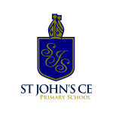
History in EYFS

Nursery | Understanding the World |  | - Begin to make sense of their own life-story and family’s history.
Reception | Understanding the World |  | - Comment on images of familiar situations in the past.  - Compare and contrast characters from stories, including figures and the past.
Early Learning Goals | Understanding the World | Past and Present | - Talk about the lives of people around them and the roles in society.  - Know some similarities and differences between things in the past and now, drawing on their experiences and what has been read in class.  - Understand the past through settings, characters and events encountered in books read in class and storytelling.

